How JavaScript Works

In JS first phase is compilation phase but it does not compile the code to machine code.

In C++ compilation there are many phases like

1)Lexical analysis

2)Syntax Analysis

3)Semantic Analysis

4)Intermediate Code generation

5)Code Optimization

6)Target Code generation

These are 6 steps in compiler design theory(GATE syllabus).

In JS during compilation phase, it checks for any error in code and also check scope for variables that is Determining Appropriate Scope for variables.

Then comes the Code Execution Phase: In JS code executes inside **execution context**

and the first execution context that gets created is called **Global Execution context.**

Check below diagram for better clarity in short.

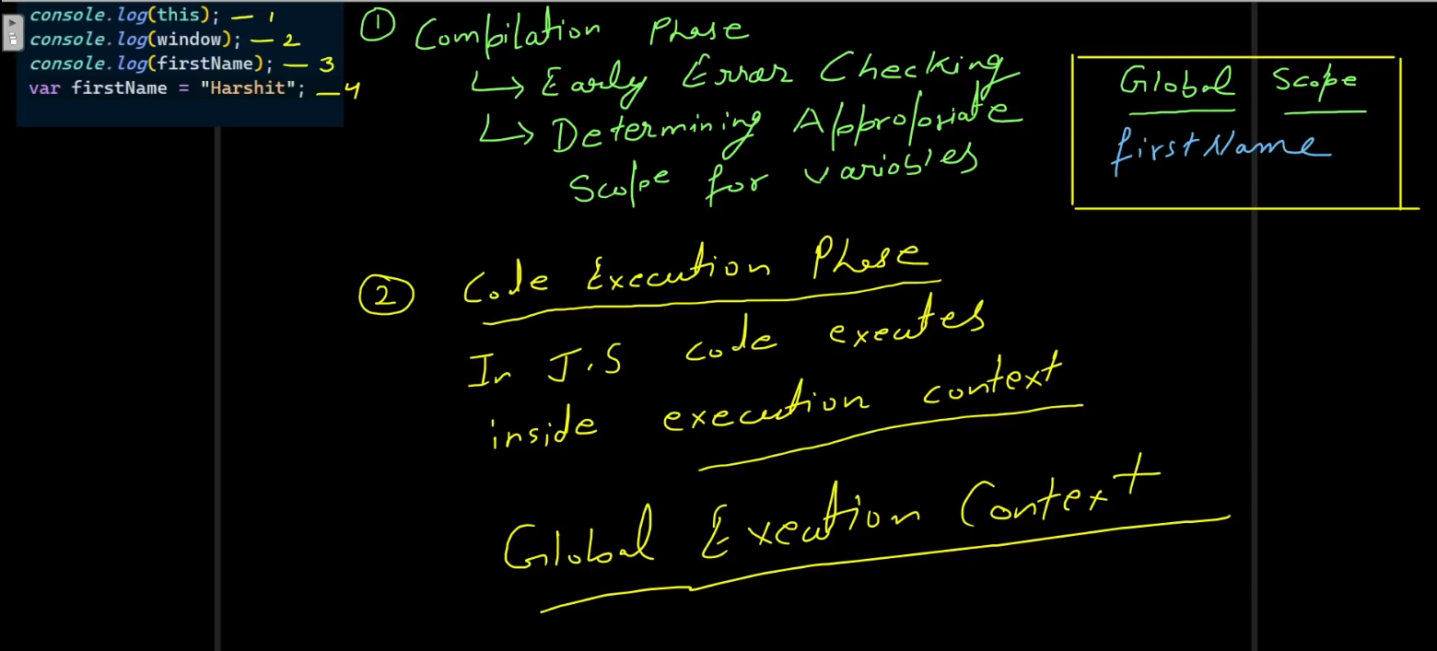

Now let’s dive deep into GEC (Global Execution Context)

There are two things in GEC one is creation phase (whose creation phase : The creation of GEC phase only) and another is code execution phase

Let’s say we have a variable in our code ‘firstName’ so in creation phase(We already know the scope of variable in compilation phase) the variable will get undefined value.

And all variable have same thing as above. We are talking about ‘var’type variable only now.

‘this’ value will be determined in creation phase of GEC

‘this’ value will depend on the environment that is if in browser then HTML DOM will set it’s value to ‘window’ object and in NodeJS environment we get different value.

In our example we have everything in **global scope**.

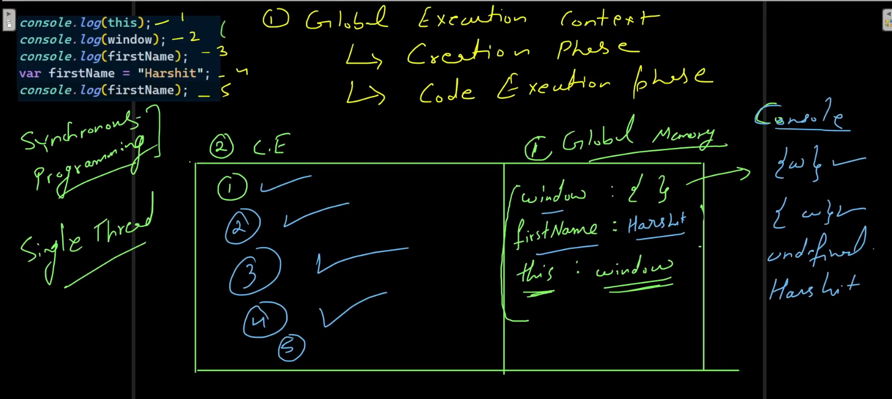

Now let’s see the 5 line code in above image let’s see how it gets executed.

1. Will print ‘this’ value to console as determined in GEC i.e. window object
2. Will print window object only
3. Since till here the value of firstName is undefined as determined during GEC therefore will print ‘undefined’ only
4. Now this line assigns “Harshit” to firstName var
5. Now this line will print value of var firstName i.e.

Print “Harshit” to console.

Now some things to remember about JS

1)JS is by nature a Synchronous Programming language

Synchronous Prog. Means that it will not execute line number 2 ,3 or next lines before executing line 1

2)JS is single threaded

This means **it has one call stack and one memory heap**. As expected, it executes code in order and must finish executing a piece code before moving onto the next.

The current GEC is stored in a stack and once get executed gets popped off.

See below example of code till first phase of GEC

All these variables in global memory are also saved as object in key value pair also known as **global variable record** in official ECMA doc

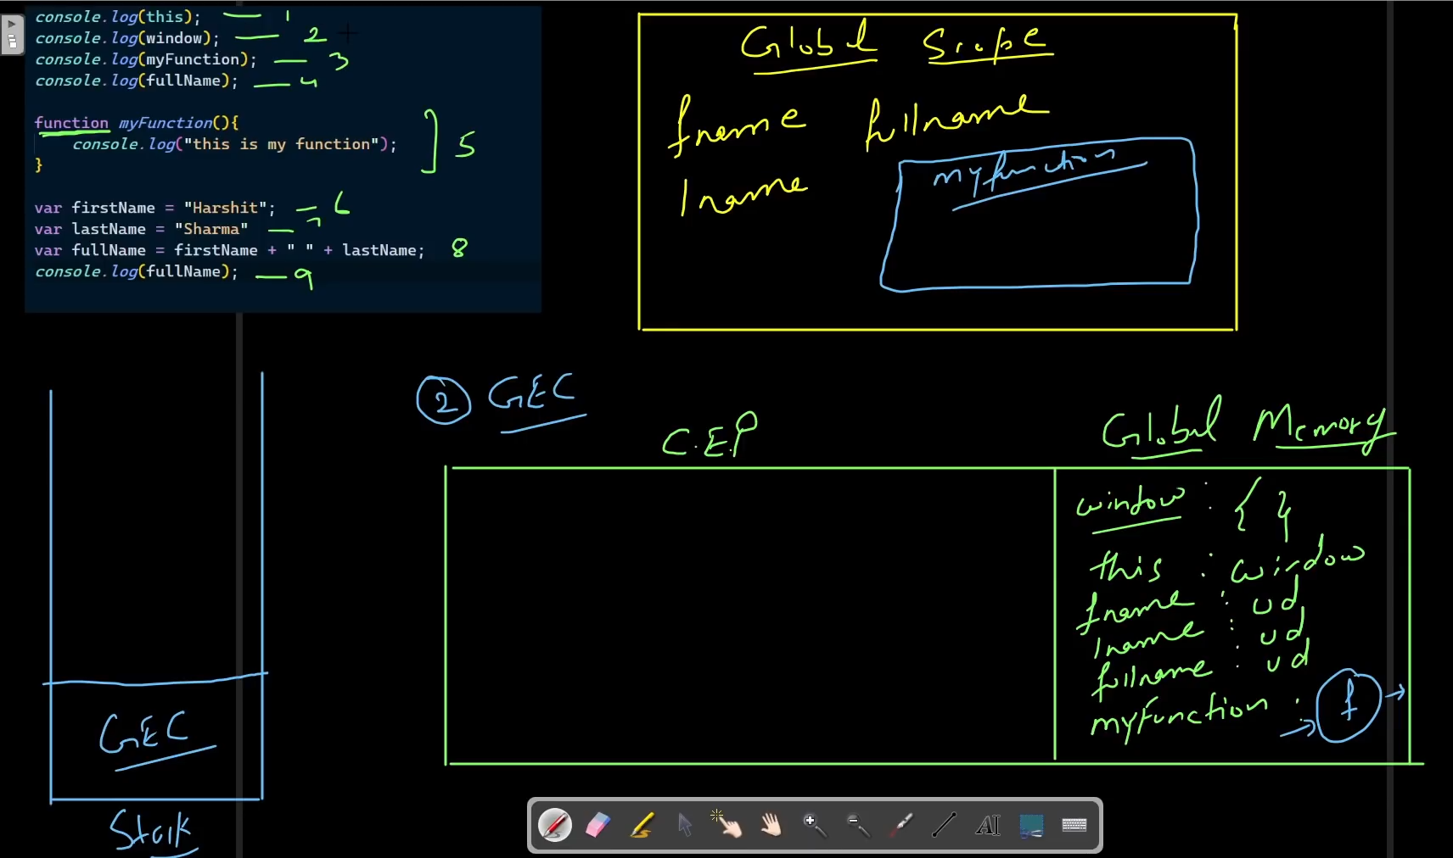

Now pic after completion of execution phase

1)’this’ value get printed

2) window object will get printed

3)myFunction will get printed

4)undefined will get printed (you already know why as discussed in above example)

5)ok so function is there nothing will get printed here

6)value of firstName set to “Harshit”

7)value of lastName set to “Sharma”

8)value of fullName set to as “Harshit Sharma”

9)print value of fullName as assigned in above line

Important thing here is 3rd line that prints complete function. Why that happens

During compilation phase global scope of variable gets defined this also shows the JS the presence of variables and function and on the basis of this information in GEC phase the global memory gets created and variables get undefined (in var case) and the complete function whatever is there inside of it. This is called hoisting

**Hoisting** : JavaScript interpreter splits the declaration and assignment of functions and variables: it "hoists" your declarations to the top of their containing scope before execution.  
This is the definition available in market and says exact same thing as explained in above para.

That is why in execution of 3rd line of code the complete function gets printed on console.

Here we have seen function declaration but other functions have other concepts which will be explained later.

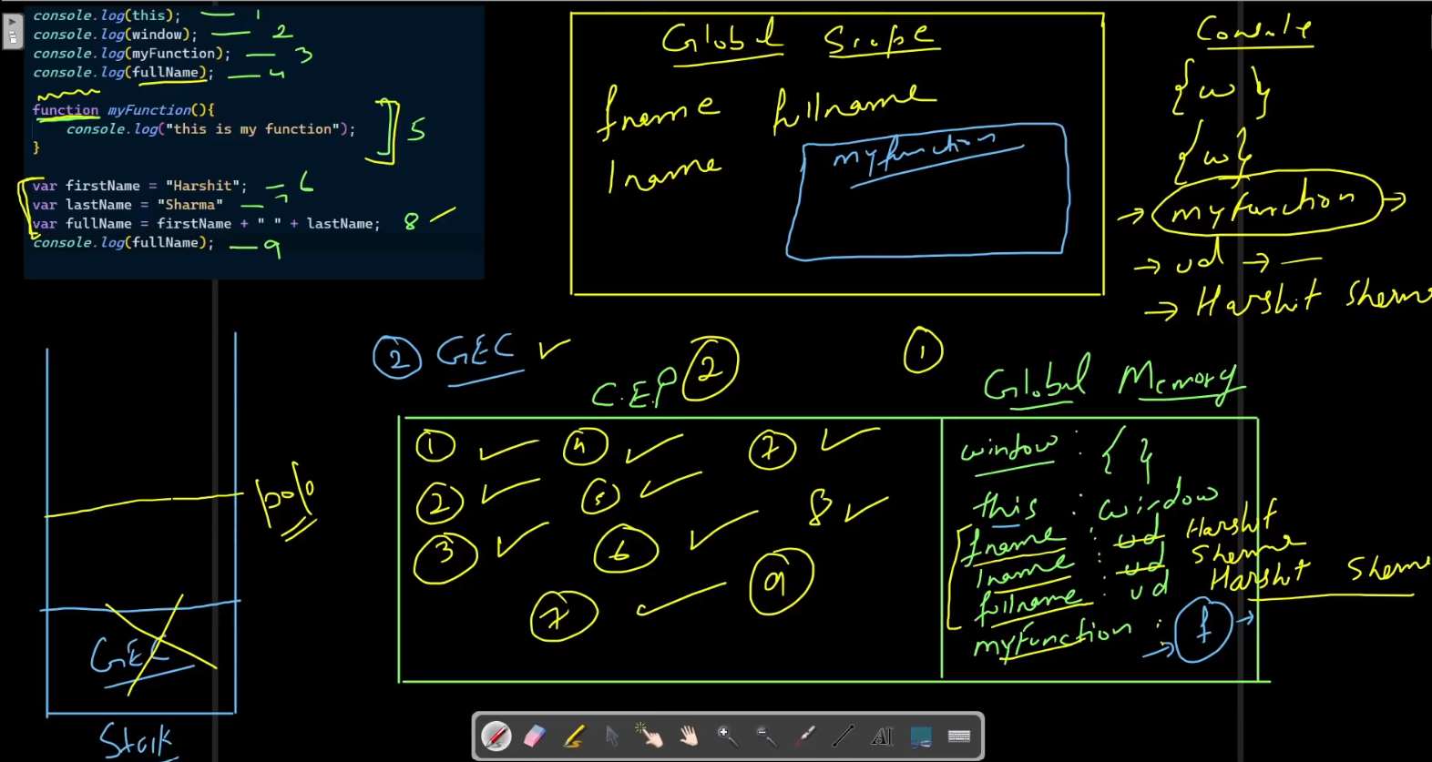

**Function expression with var variable**

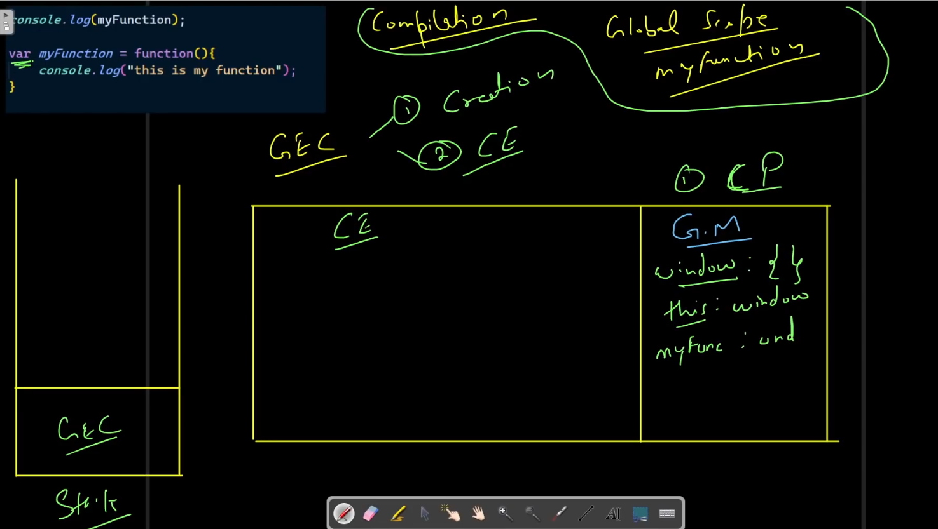

Now see the above example, we have code in top left corner after the completion of GEC creation phase and we have Global Memory created.

Since the anonymous function is assigned to a var variable this will have same fate as of a var variable that we have seen in previous examples.

Now lets see the execution part

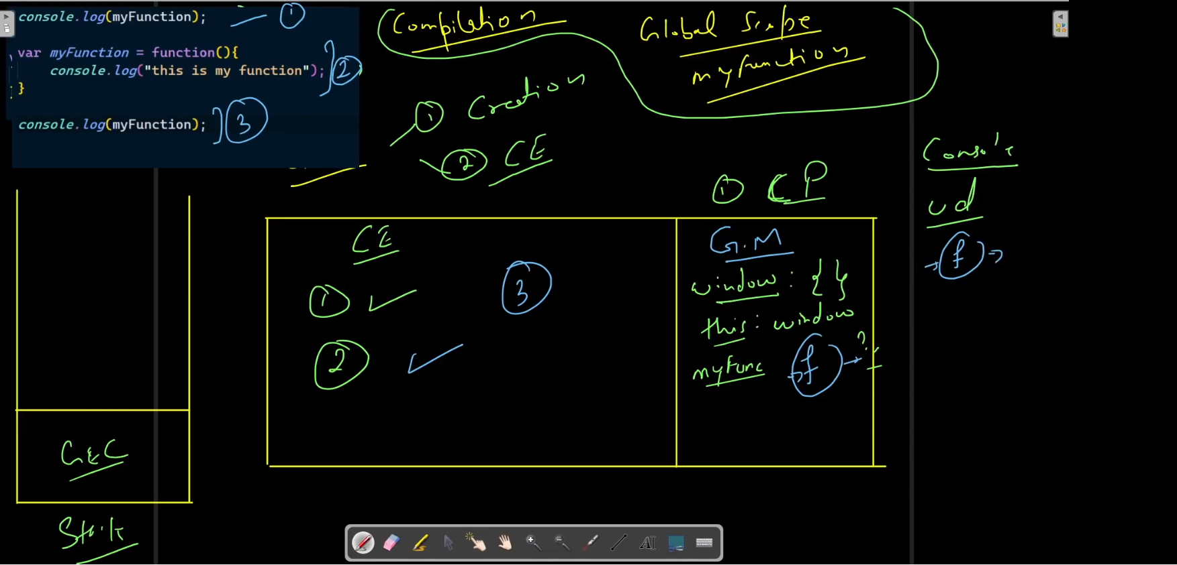

1. Line will print undefined because JS assign undefined to var myFunction when creating GEC.
2. Will assign myFunction as written in code and the value of myFunction will change in Global Memory.
3. Will print the whole function now.

Till now we have how var variable are executed in JS.

Now lets see it for let and const variable and function expression.

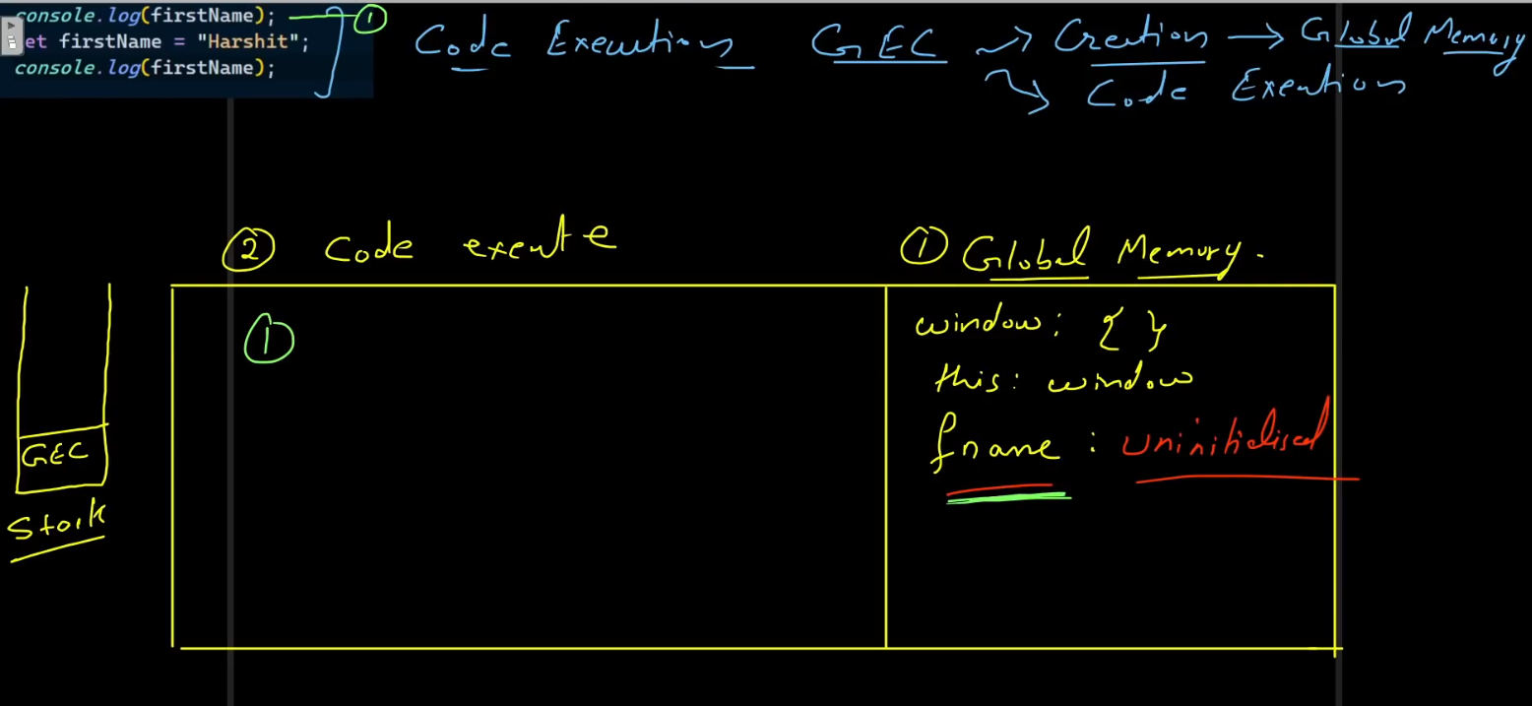

Now lets see the example code in top left corner. We have a let variable here.

During GEC creation phase in Global Memory the value of let variables are assigned as uninitialized.

And because of this the code will give an error since we are directly printing the variable firstName which is not initialized by as before printing it.

The error is : ReferenceError: Cannot access 'foo' before initialization

**NOTE:** Now one can wonder why I am not desired error when I write same code in my browser chrome now they do something like they change our let to var in background which will give same result as below for the code.



But if we have code like this:  
*console.log(firstName);*

If we have this above line of code then it will give same error as given in mention in NOTE section above.

**TDZ (Temporal Dead Zone)**

The zone or scope from where the variable is declared till where the variable gets assigned or initialized is called TDZ.

Extra theory from FCC

The reason that we get a reference error when we try to access a let or const variable before its declaration is because of the temporal dead zone (TDZ).

The TDZ starts at the beginning of the variable's enclosing scope and ends when it is declared. Accessing the variable in this TDZ throws a ReferenceError.

Here's an example with an explicit [block](https://developer.mozilla.org/en-US/docs/Web/JavaScript/Reference/Statements/block) that shows the start and end of foo's TDZ:

{

// Start of foo's TDZ

let bar = 'bar';

console.log(bar); // "bar"

console.log(foo); // ReferenceError because we're in the TDZ

let foo = 'foo'; // End of foo's TDZ

}

The TDZ is also present in default function parameters, which are evaluated left-to-right. In the following example, bar is in the TDZ until its default value is set:

function foobar(foo = bar, bar = 'bar') {

console.log(foo);

}

foobar(); // Uncaught ReferenceError: Cannot access 'bar' before initialization

But this code works because we can access foo outside of its TDZ:

function foobar(foo = 'foo', bar = foo) {

console.log(bar);

}

foobar(); // "foo"

typeof**in the temporal dead zone**

Using a let or const variable as an operand of the typeof operator in the TDZ will throw an error:

console.log(typeof foo); // Uncaught ReferenceError: Cannot access 'foo' before initialization

let foo = 'foo';

This behavior is consistent with the other cases of let and const in the TDZ that we've seen. The reason that we get a ReferenceError here is that foo is declared but not initialized – we should be aware that we're using it before initialization

Now lets see some more examples to understand more 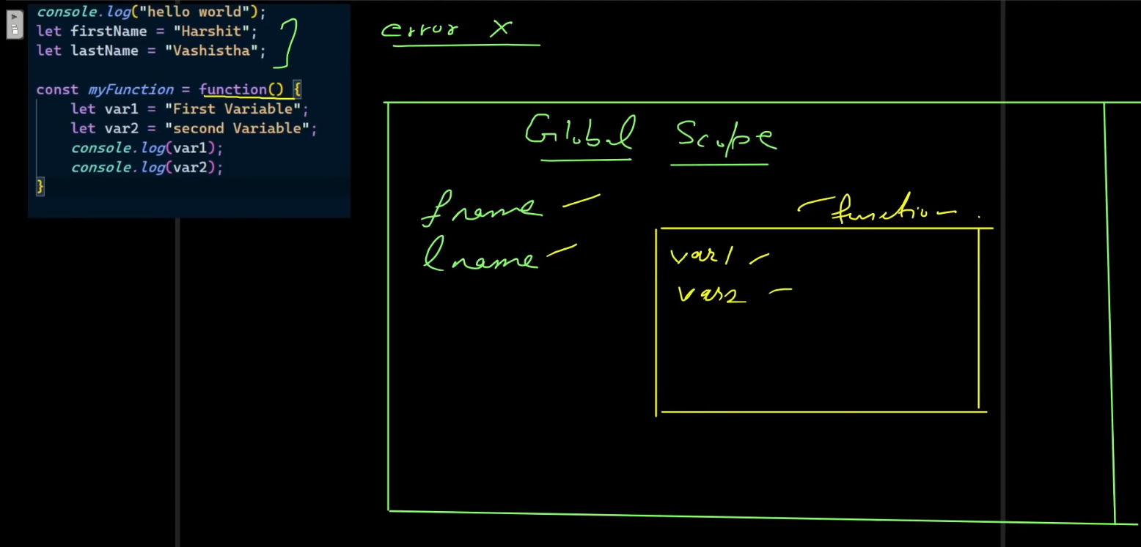

The code is error free and after compilation phase global scope is also created.

The scope of variables inside functions are also known to JS as it can parse the code.

Now lets take another example, now we directly talk about GEC thing and we have enough knowledge to understand the scope and value of variables after compilation face.

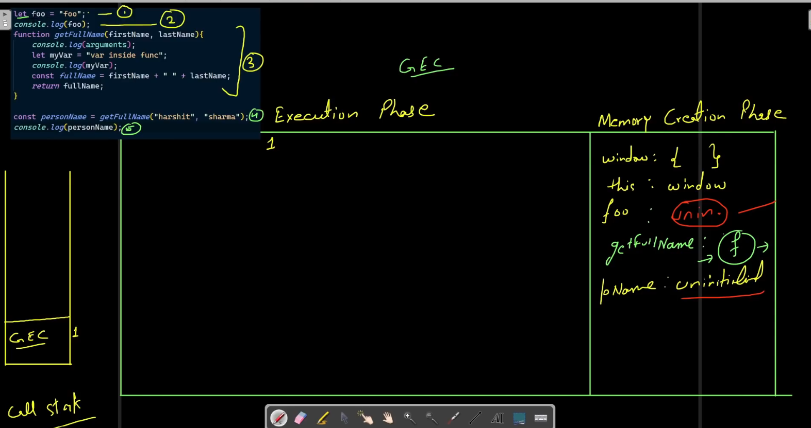

Again code is error free and we have created the global memory and observe carefully here that even the scope of variables are known to JS still we don’t see any variable’s that are inside the function and have local scope in memory creation phase.

Now lets see execution phase.

1. The value of foo variable is assigned
2. The value gets printed to console i.e. “foo”.
3. Function declaration will be read by JS
4. Now here comes the main thing of this example

Observe very carefully.

Since there is a function declaration here, so inside code execution there will again be something we can call function execution context in which again we have two phase one is the creation of this function execution code only and another is local memory creation.

Here the first thing in local memory is argument and it is an array like object that means it has a length and index.

Other concepts are also same inside FEC for variable value like undefined and uninitialized for var and (let,const) respectively.

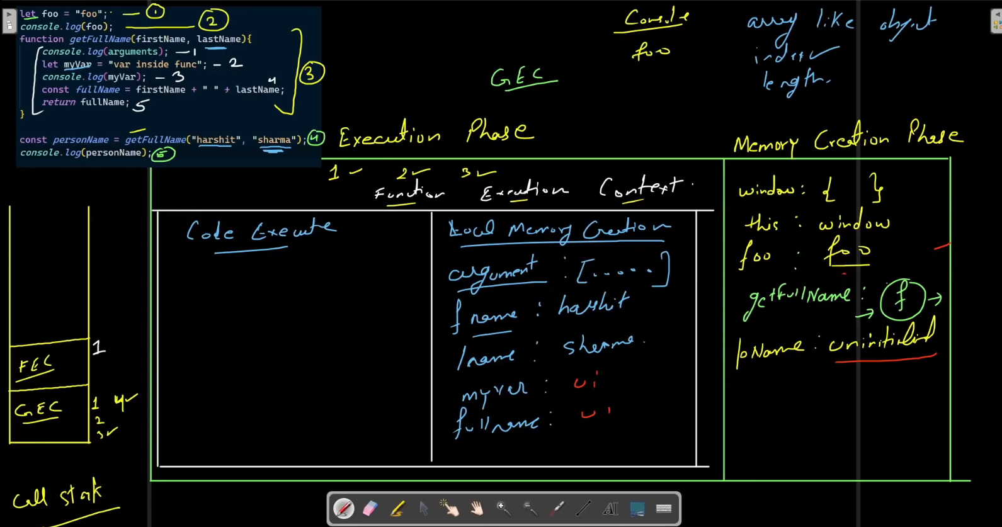

Now lets execute the FEC

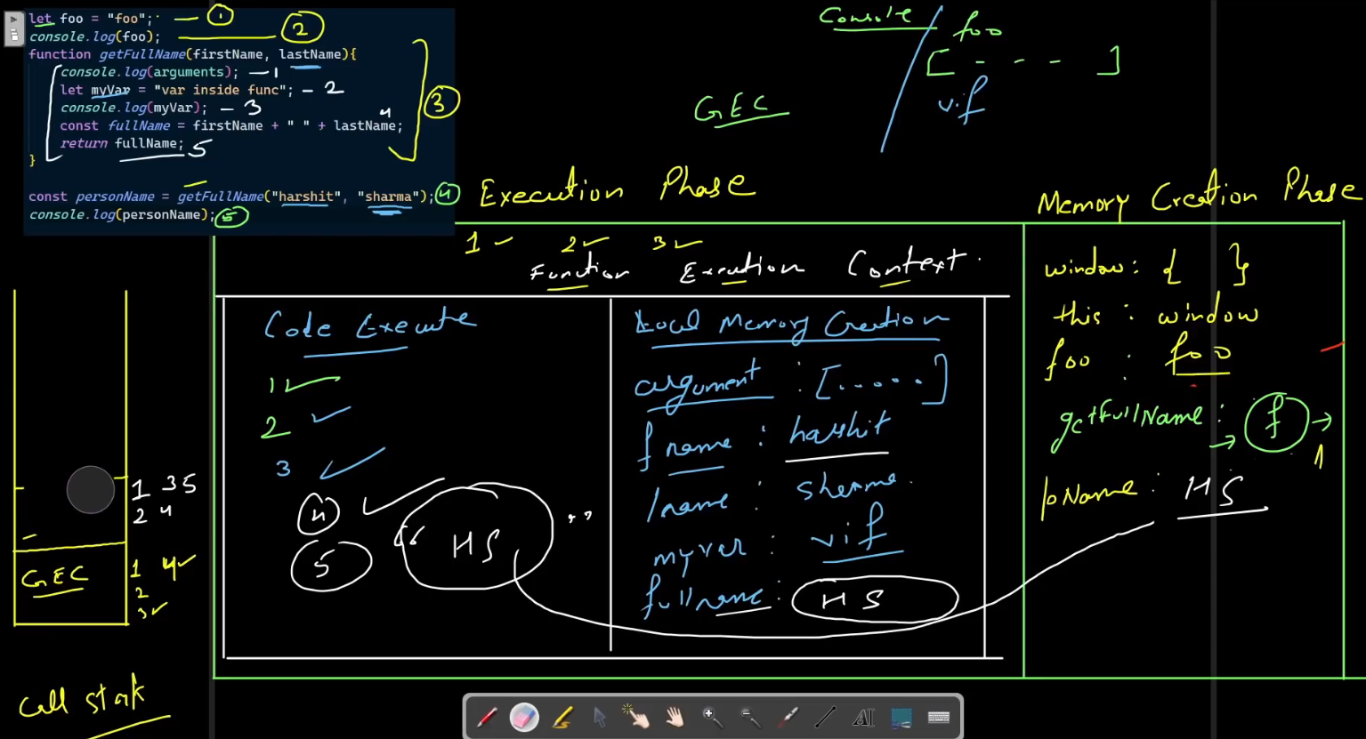

Inside function lets start with

1. It will print arguments to console



1. It will assign value to myVar
2. Will print myVar to console
3. Will assign value to fullName as written in code
4. Will return to GEC memory creation phase and will assign value of personName.

Now the FEC stack will get popped off after returning value

And now the 5th line of our whole code will get executed and will print the value of personName returned from function.

And after the completion of GEC the call stack of GEC will also get popped off.

Now let’s see another example

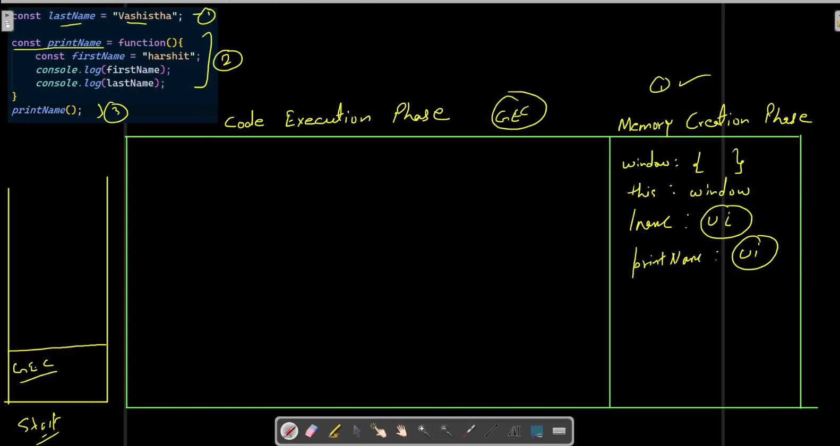

Till here we have completed the first phase of GEC and will start execution.

1 and 2 line will get executed and when the 3rd line starts to get executed then our FEC is also created.

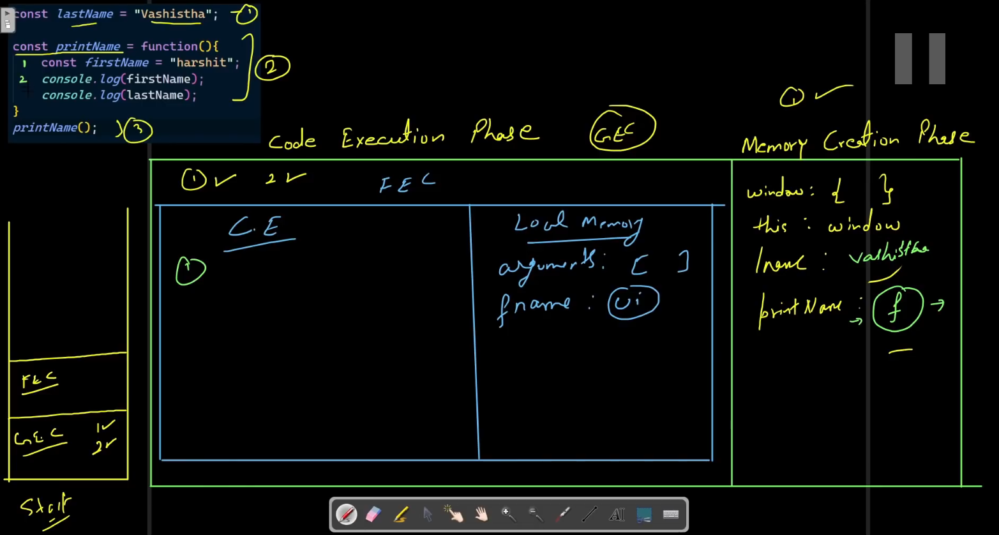

Till here we have completed the local memory creation or first phase of FEC.

And will start executing the lines inside function.

So first 2 lines will get executed as usual.

Now when it executes 3rd line inside function it is to be observed carefully here. And that is it will not find the variable named “lastName” in local memory so it will then search for it in its just parent scope(since we are currently present in FEC and the FEC is inside GEC so it will check it in GEC’s global memory) and in our case it is the global scope so it will check it in global memory since the variable is lexically present

In cases when we have multiple nested scopes then JS will find the required variable in next outer scope till it reaches the global scope or If it finds the variable

Lexical Environment is one of the under the hood topics in JavaScript. When we talk about execution context, execution environment, variable environment or lexical environment all of these things ultimately defining what's called scope. The scope is where a variable is available in your code

<https://javascript.plainenglish.io/scope-chain-and-lexical-environment-in-javascript-eb1f6e60997e>

This article is good because we have already seen what is execution context and lexical environment and such things but to add more technical taste to it we can refer to this link.

Closures in JS

So, again lets take and example and learn it.

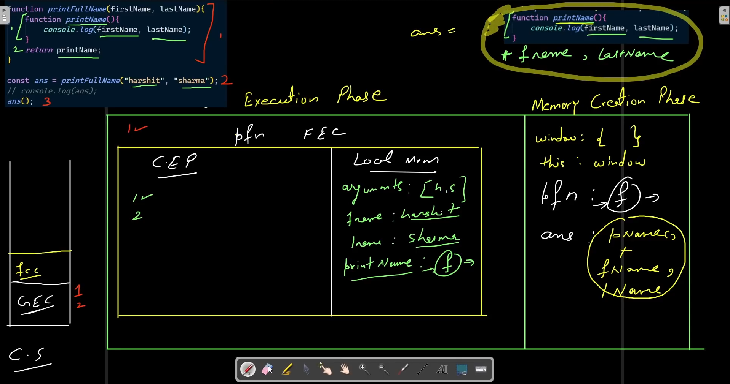

We already learn so much from previous examples that we can easily reach to the FEC stage (I mean from diagram point of view) and lets continue from there to be short and precise.

When 2nd line of whole code get executed then it will have to go for FEC and FEC stack will get created.

So we have FEC of printFullName(arguments) method and we start its execution.

1. First line is already there in memory we it’s done.
2. 2nd line the return of function printName(). This is the most important thing to learn and observe here.

So we know that our printName() method uses two arguments from its outerscope or parent i.e. firstName and lastName. So when our printName() method will get returned and gets stored in ans variable in global scope it will not just take the printName() method with it but also take those two variable memory with it.

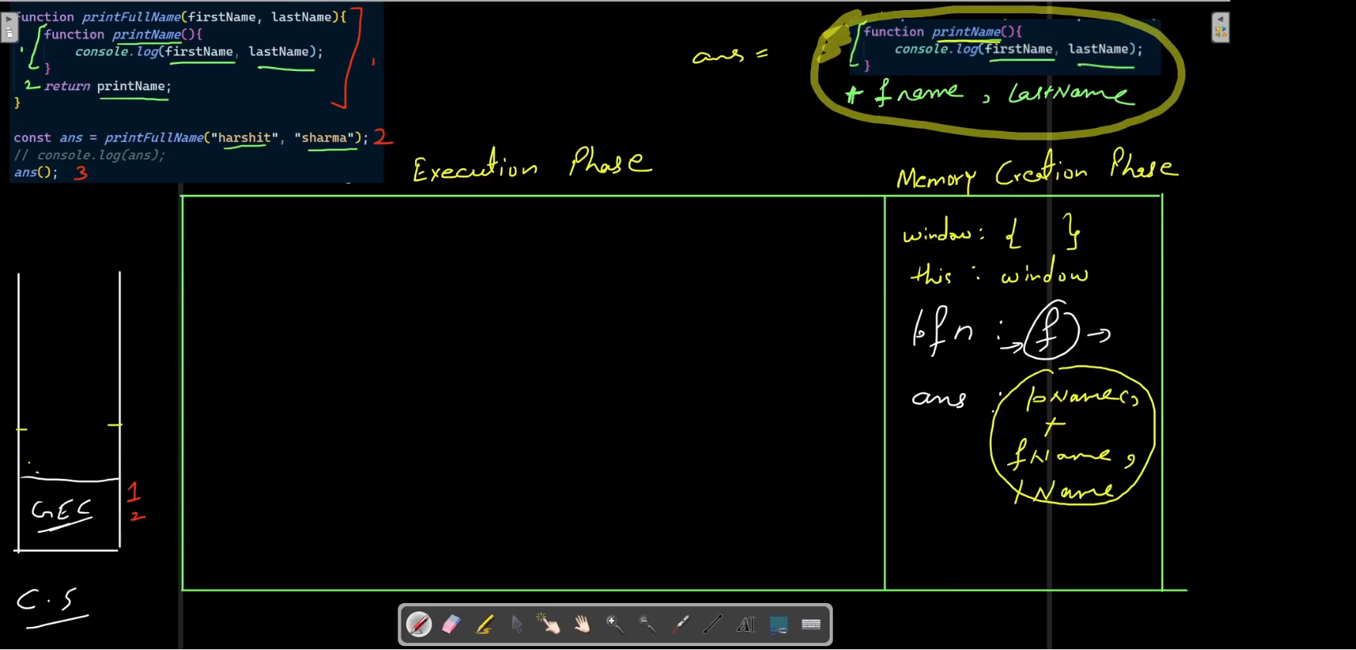

Now we are here at this point and will execute line 3 in GEC and it again has to create a FEC since answer contain printName() + firstName+ lastName with it.

Check below photo for next stage.

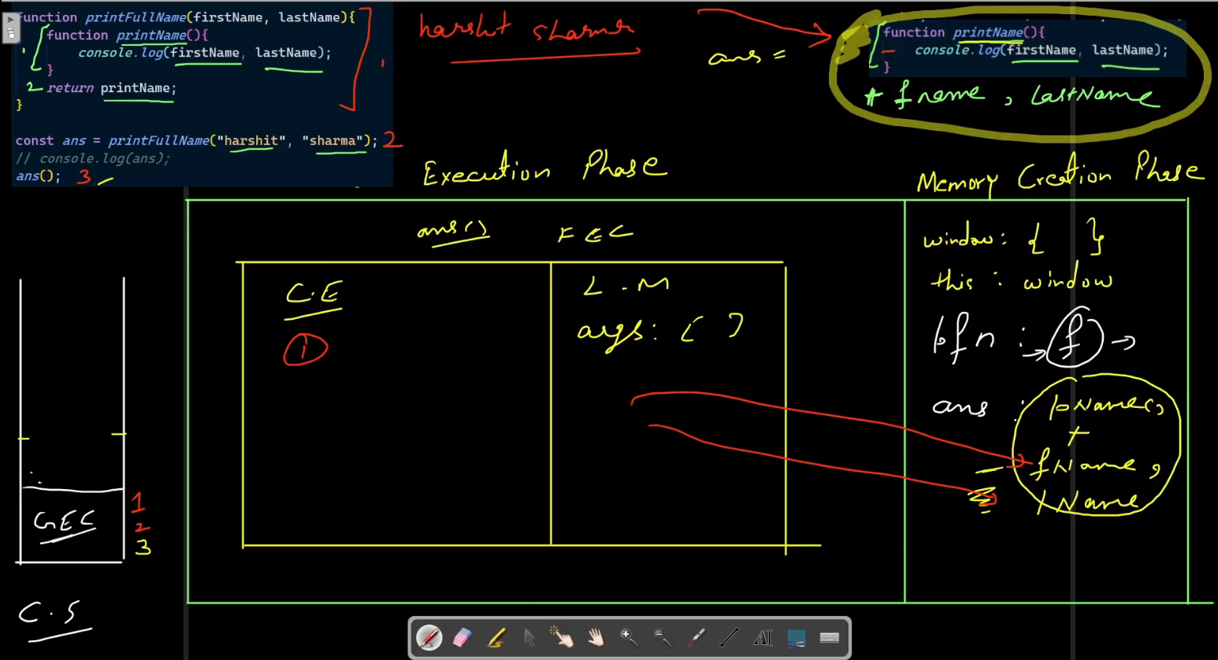

So this is the whole picture of closure.

So when the function (like in our code printName()) gets returned then it will not just return the function will also take away with it, it’s lexical environment. So that the inner function can access the things which are in outer function.

This is what called as closure.

Will take more examples to understand more.

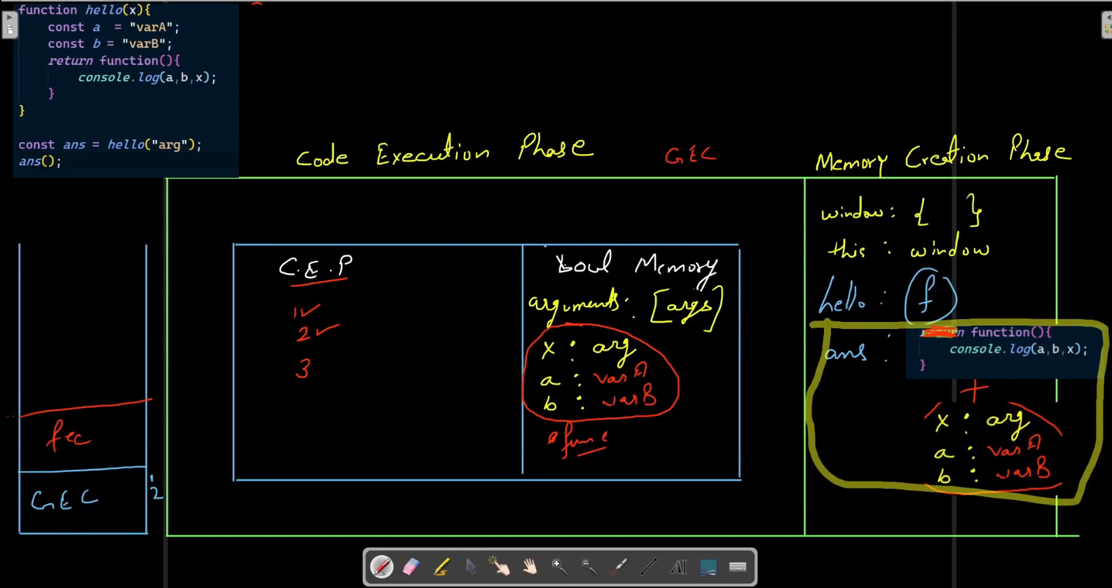

Take the code snippet given in top left corner of above image as example.

We have directly at the stage when we are returning out function inside hello() function, in order to save time and keep notes short.

So it will also pop off FEC from stack after returning.

And we can see that when our function get’s returned it is also taking away the lexical environment of FEC with it to global memory.

So that the function which gets return can use those variables outside of the scope of hello();

This is again called closure.

Now I have one question

Does it makes our local variables declared inside hello() method/function global??

Well, I have not verified it but it looks to me like it is making those local variable global.

Now our 3rd line of whole code will get executed like this as shown in image below.

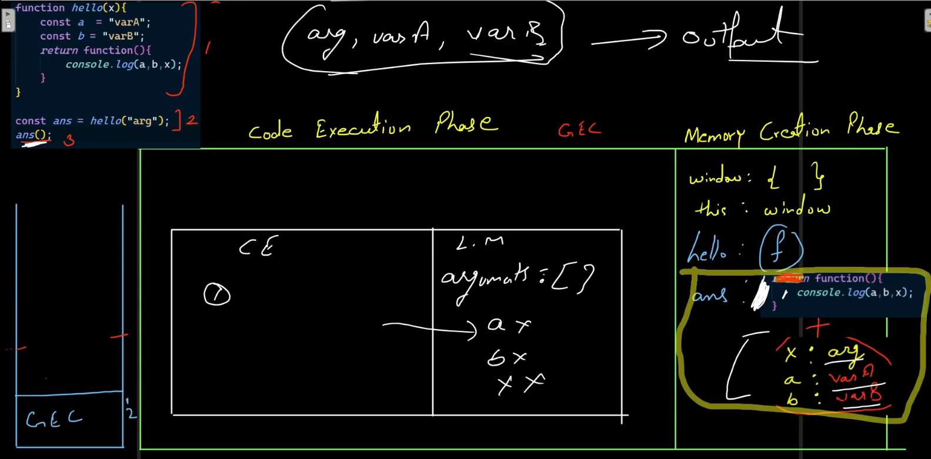

Since we are calling ans (since it contains an function we say we are calling ans() function) it will again create a FEC but this time be carefull that we don’t have those variables a,b,x inside this FEC’s lexical environment. All those values will be taken from global memory.

Now let’s take another example.

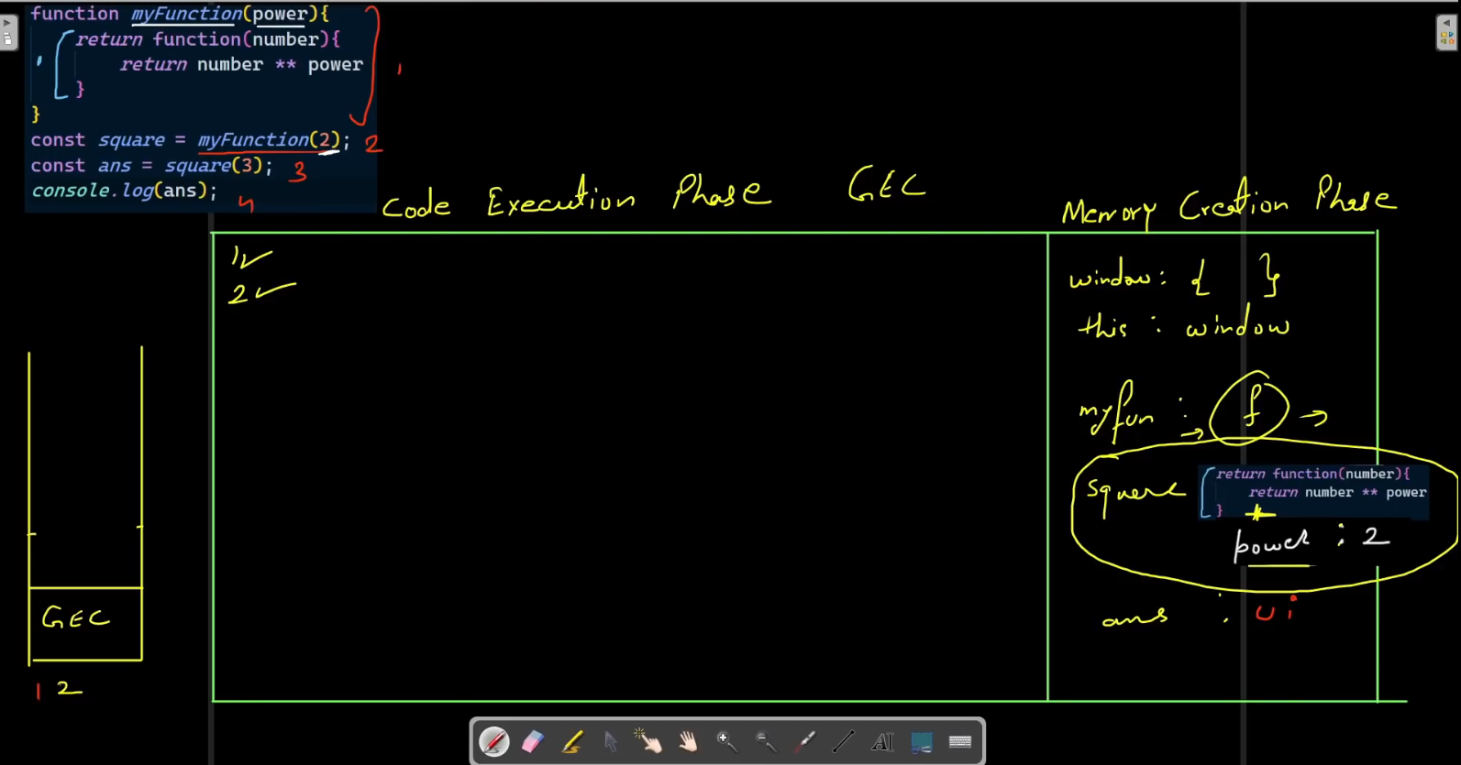

We are again here bypassing some steps and directly coming to the point where we have done our execution of line 2 as visible in code snippet in top left corner in above image.

And the whole lexical environment is in global memory now.

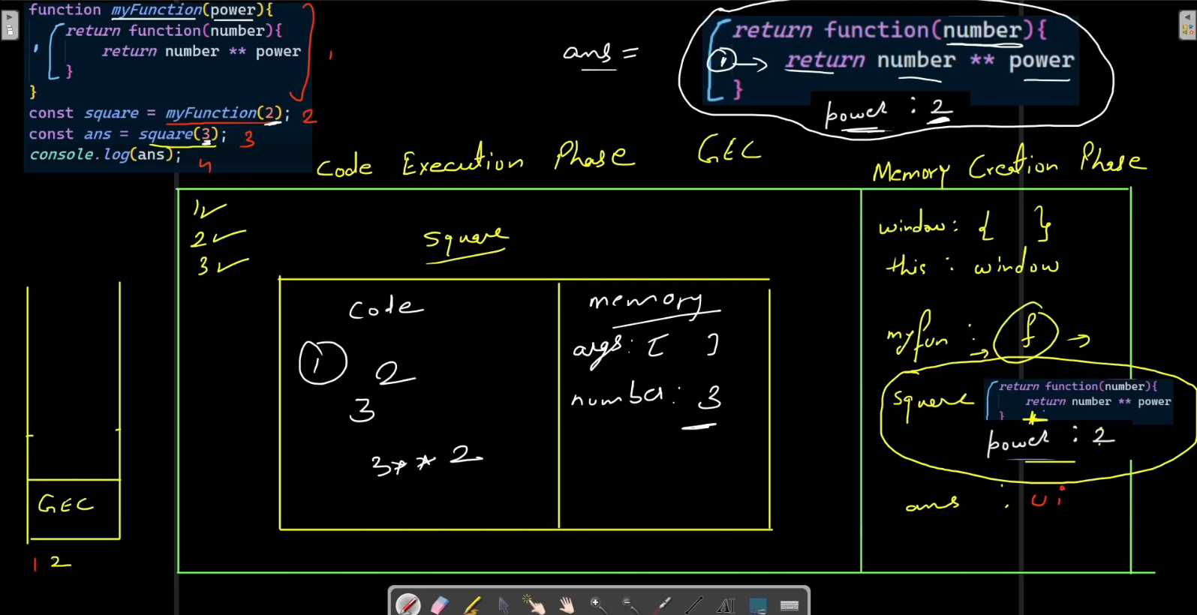

Here the most important thing to observe here is that what this square variable contains? It contains whatever return by myFunction(2) and that means it contains the code snippet as shown in top right

i.e. function(number){

return number ** power;

}

+ power = 2 as we know that closure is there so it will also take away its lexical environment to global memory.

So square actually contains the code snippet as shown in top right

Now we will start executing line 3.

We are calling square(3) from the above observation we can say that for this FEC we have number argument assigned as 3 and we already had power variable assigned to 2.

So what this ans variable will contain? It will contain whatever it is return by square(3) and it returns

number** power;

and hence it will return 3 power 2 that is 9.

Let’s execute line 4 of whole code.

It will print 9 on console.

------------xxx---------------The End---------------------------xxx--------